Working Towards Racial Equity: Systems Change through Individual Transformation

By Valeria F. Romero and Melissa A. Collins with Kelly Grindstaff, Aujaneè Young, and Jedda Foreman

# Introduction

In 2019, the Lawrence Hall of Science, Justice Outside,[1] and Informing Change[2] received funding from the National Science Foundation to develop a capacity-building model that would support environmental learning organizations to center racial equity and justice in the work environment. This project was in response to long-standing racial inequities that have disproportionately impacted Black, Indigenous, and Communities of Color within the environmental field. Working Towards Racial Equity (WTRE) was guided by the Water of Systems Change (Kania, et al., 2018) framework that suggested that, to advance racial equity, organizations must attend to the structural aspects (policies, practices, plus resource flows), the relational aspects (relationships and connections, along with power dynamics), and the mental model aspects (such as guiding beliefs and ideologies) of an organization.[3] Central to this framework was a prioritization of people-centered change—one that grounds change in historical understandings of racism in the environmental field and society, applies understandings to change at both individual and organization levels, and sustains change through trust building, community, self-care, and reflection.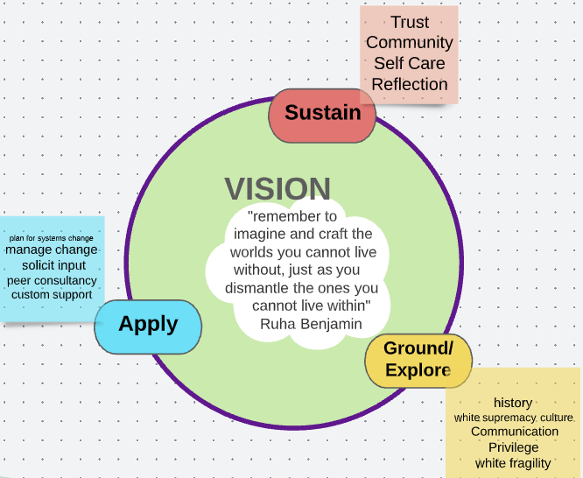

To this end, the Lawrence Hall of Science led a research study to understand how participants’ perceptions and experiences, as related to equity, leadership, sense of belonging, and professional growth, changed over the course

of WTRE. In this brief, we explore how all participants’ perceptions shift over time, and whether there are any specific patterns or insights we can learn from the experiences of People of Color who participated in WTRE, in particular.

# Program Context

WTRE is a capacity-building model that invites staff members from outdoor and environmental learning organizations to learn about race and white supremacy culture[4] as a means towards enacting organizational change efforts that center racial equity and justice. This brief reflects on a model of WTRE that operated from 2020 to 2023. WTRE engaged two cohorts of 10 organizations each (20 organizations total) over two years in systems-change racial equity efforts. Central to this model were two strands of participation: (1) an organizational systems change strand (OSC) and (2) a Professionals of Color (PoC) strand (see Figure 1).

**OSC.** The OSC strand was composed of teams of staff members from each organization who represented various departments, roles, and positions of power within their organization. It was also encouraged that there be representation across racial and ethnic identities that are disproportionately impacted by systemic racism—namely, staff members who identify as Black, Indigenous, and/or a Person of Color[5]—though this was not the case across all organizational OSC teams. Together they would lead change efforts at the organization with their colleagues.

**PoC.** The PoC strand was composed of any person of color at each participating organization. This could include any staff member who identified as Black, Indigenous, and/or a Person of Color, whether or not they participated in the OSC thread. This group of people had distinct programming that focused on centering joy, healing, and liberation while working in predominantly white institutions. While they could engage in change efforts and/or be a member of the OSC strand team, this was not a requirement.

Figure 1. Working Towards Racial Equity Program Model

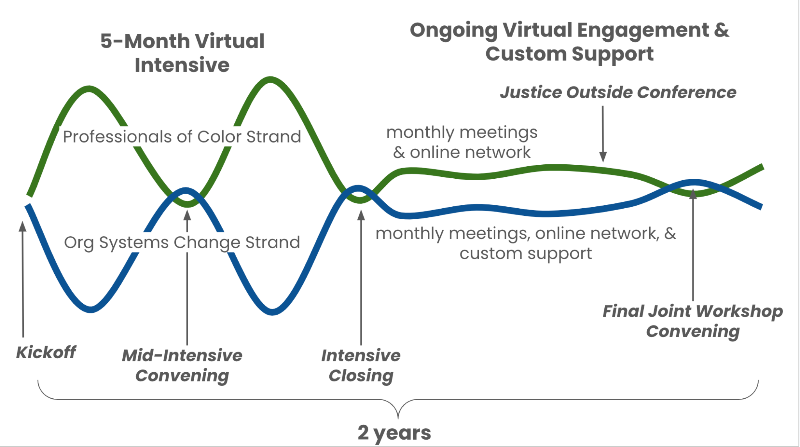

Participants in both strands (OSC and PoC) engaged in a series of programming over two years, beginning with a virtual intensive series, followed by ongoing coaching and custom support. The intensive series was focused on first developing an understanding of key concepts and then identifying barriers to equity at each organization. In subsequent virtual sessions, teams continued to “identify barriers” (with input and feedback from their staff), and made action plans to address those barriers. Over this two-year period, the OSC and PoC strands received differentiated programming that aligned with the goals for each strand. Members of the PoC strand were also invited to attend all OSC programming.

# Methods

## Research Purpose and Questions

This study is part of a broader multi-year research project that aimed to understand how organizations enacted systems change efforts, and how individual people’s experiences and perspectives shifted over the course of WTRE within the context of such efforts.[6] This paper focuses on a subset of data that explored the extent to which, and in what ways, participants’ perceptions related to understandings of equity (their own in relation to their organization), as well as their experiences engaging in leadership, opportunities for professional growth, and sense of belonging, shifted over the course of WTRE. Specifically, we were interested in answering the following research questions:

* To what extent and in what ways do WTRE participants’
  + perceptions related to leadership, professional growth, and sense of belonging shift throughout WTRE?
  + understandings of equity and inclusion shift throughout WTRE?
* Which factors do participants attribute to those perceptions and experiences?
* To what extent, and in which ways, do participants identifying as Persons of Color experience and then form a sense of belonging in their respective organizations?

## Data Collection

Participants completed three surveys: a pre-survey, conducted before participating in any project activities (T1), a post-intensive survey, after completing the five-month intensive virtual series (T2), and an end-of-program survey at the conclusion of the two-year program (T3), in which they shared their final perspectives. Below we describe each of the four scales included in the three surveys.

## Survey Design and Constructs

This collaboratively developed survey included four key constructs of interest: (a) sense of belonging; (b) leadership; (c) professional growth; and (d) shared understanding. The Lawrence Hall of Science team developed survey items for sense of belonging, leadership, and professional growth, based on an extensive literature review and on the content within the WTRE program. After a draft of the survey was developed, the team sought feedback from a research and evaluation advisory group, which was composed of outdoor and environmental science education (OESE) staff members who had participated in the pilot of WTRE in California. Advisory members were asked to rate items based on relevance, clarity, and which constructs they would prioritize. The team then reviewed feedback and refined each of the survey items. Shared understanding items were developed by the Informing Change team, in close collaboration with both the Lawrence Hall of Science and Justice Outside teams. These items were developed to specifically gain an appreciation of how one’s own understandings of equity, inclusion, and social justice (three concepts of particular focus in the WTRE program) aligned with those of the organization. Each construct is discussed further below, and reliabilities for each scale are included in Appendix A.

### Sense of Belonging

The *Sense of Belonging Scale* originally included 17 items to assess the extent to which individuals feel supported by, and aligned with, their organization. Responses were on a 4-point scale: 1: 'Strongly Disagree'; 2 'Disagree'; 3 'Agree'; 4 'Strongly Agree.’ The full scale included three subscales: *Social Connections* (e.g., “I feel cared about as a person at work”), *Organizational Identification* (e.g., “I feel proud when I talk about the work I do at my organization”),and *Authentic Self* (e.g., “My social identities are respected by my colleagues”). Following initial analysis done after the post-intensive (T2) survey, four items were removed to limit redundancy. Mean scores reported for all timepoints include only the final 13 items.

### Leadership

The *Perceptions of Leadership Scale* originally included 16 items along the same 4-point scale: (1. 'Strongly Disagree'; 2. 'Disagree'; 3. 'Agree'; 4. 'Strongly Agree'). The scale also assessed the extent to which an individual perceives their organization’s leadership (themselves included) to respect its staff, be receptive to input, and be transparent about processes and decision-making. The full scale originally included 16 items across two subscales: *Values Leadership* (e.g., “I can shape what leadership looks like within my role”) and *Distributed Leadership* (e.g., “When a crisis happens at work, everyone who is impacted is invited to provide input”). Again, based on the results of an initial (T2) analysis, six items were omitted and the two subscales were combined. This report includes analysis of the final 10 items only (full scale) for simplicity.

### Professional Growth

The *Perceptions of Professional Growth* scale originally included 13 items along the same 4-point scale (1. 'Strongly Disagree'; 2. 'Disagree'; 3. 'Agree'; and 4. 'Strongly Agree') and assessed the extent to which the individual was aware of and had access to professional growth opportunities at their organization. The full scale originally included three subscales at T1: *Professional Learning* (e.g., “I have as many professional development opportunities as my peers”), *Mentoring* (e.g., “I have a mentor I can go to in support of developing my career at my organization”), and *Advancement* (e.g., “I have a clear understanding of how to grow into other roles [lateral or vertical] at my organization”). Similarly to the other scales, following an initial analysis (T2), six items were removed and the three subscales were combined in subsequent surveys, resulting in the final, seven-item full scale.

### Shared Understanding

The *Shared Understanding* Scale included six items across the same 4-point scale (1. 'Strongly Disagree'; 2. 'Disagree'; 3. 'Agree'; 4. 'Strongly Agree') and assessed the individual’s sense of alignment with their organization’s definitions and practices related to equity, inclusion, and social justice (e.g., “My organization's definition of equity aligns with my own understanding and beliefs about equity”). As with the other scales, the original scale (13 items) was reduced to six items.

## Sample

A total of 187 individuals contributed surveys at one or more of the timepoints, resulting in 170 pre-surveys (T1), 141 post-intensive surveys (T2), and 122 program-end surveys (T3). A total of 87 individuals completed all three surveys. At various time points we invited WTRE participants to share different aspects of their identities, such as racial and ethnic as well as gender identity, along with information pertinent to their role. such as type of role, number of years worked in their organization, and number of years worked in the field. This information was prominently used to understand who was represented in the survey responses and who was not. For a more-detailed breakdown of respondents, see Appendix B.

Notably, over two-thirds of respondents self-identified as a woman, and just under 10 percent identified as non-binary or gender-queer or gender-expansive[7]. A total of 44 percent of respondents identified as Black, Indigenous, or a person of color.[8]

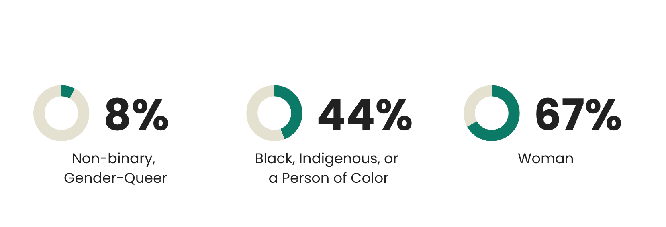

In terms of their experiences in the environmental learning field, the majority of respondents had worked in the environmental learning field (51%) and in their respective organizations (69%) for six or fewer years. In addition, there was a relatively similar representation of mid- and senior-level leadership positions, though non-leadership positions, such as interns and naturalists, were relatively underrepresented.

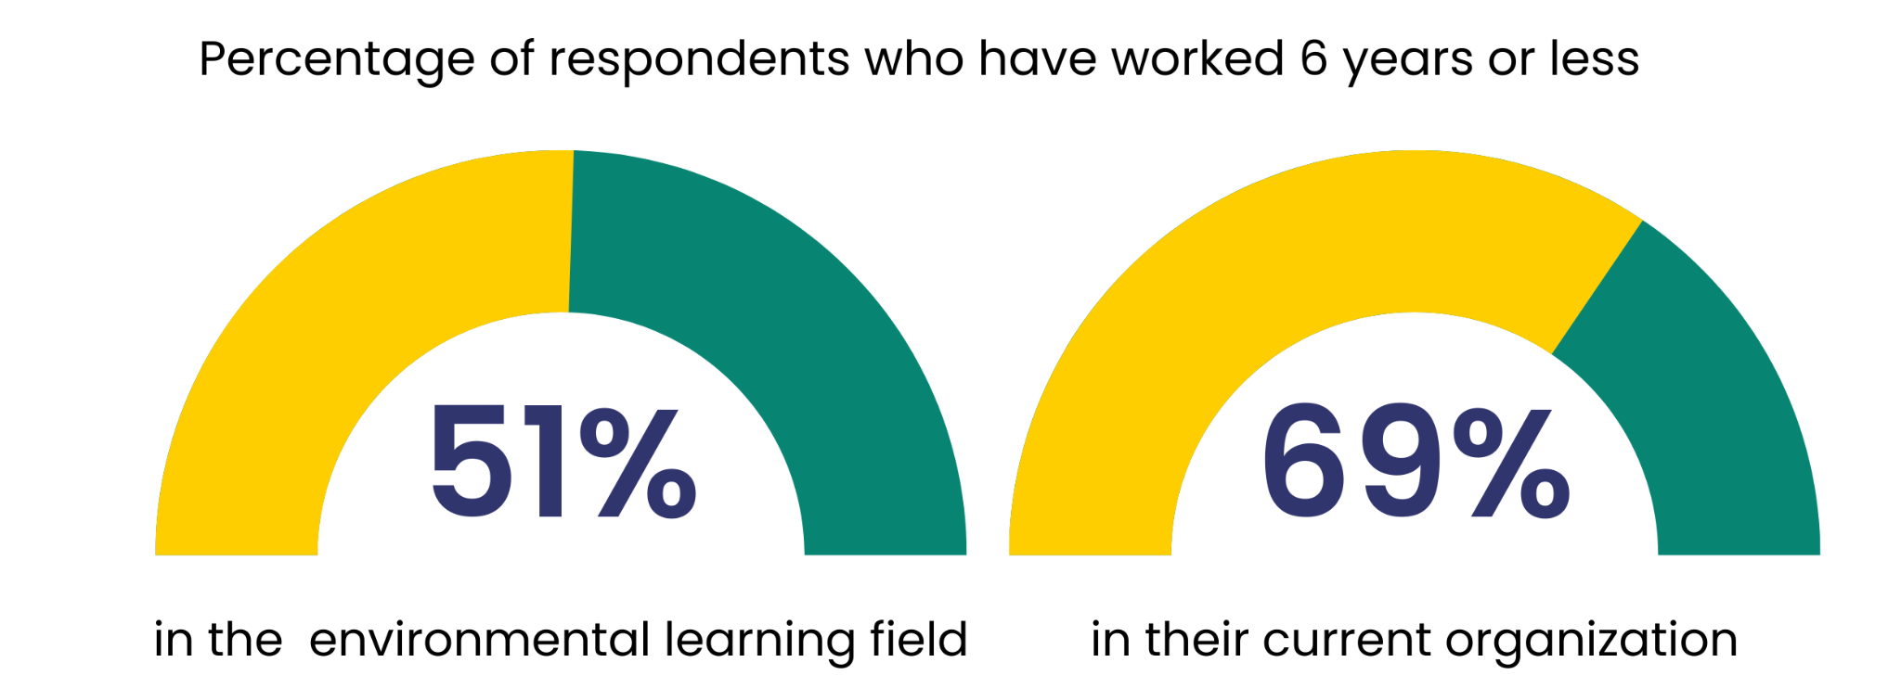

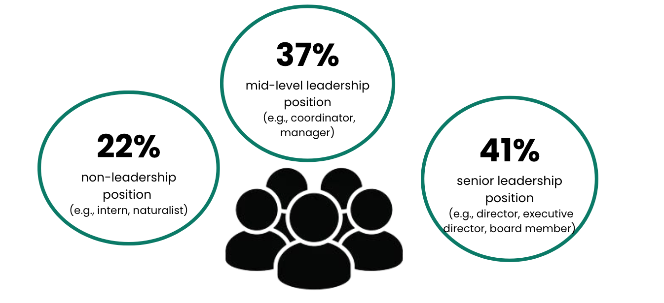

Collectively, this backdrop is important in recognizing the range of positionalities and standpoints that individuals bring to their work that shape their perspectives and experiences.

# Results

## Analytical Approach

Our quantitative analysis looked at changes in both the mean-scale scores on the four constructs of interest (Sense of Belonging, Leadership, Professional Growth, and Shared Understanding) and the subscale scores (Sense of Belonging) from pre-intensive (T1) to post-intensive (T2) and then from post-intensive (T2) to program end (T3), through a series of paired samples *t*-tests. Significant differences between timepoints are indicated by an asterisk (*) in the tables below, and Cohen’s *d[9]* effect sizes are included to allow for direct comparisons of effects across constructs. Our qualitative analysis involved multiple rounds of thematic coding. Our research team (three people) used an emergent thematic approach (identifying themes from the data) and then met to discuss how themes aligned with our constructs, as defined. We each reviewed every team member’s coding for interrater reliability, which resulted in our first refining our codebook and then doing one more round of coding. For this brief, we identified illustrative quotes from our coded data to provide depth to the statistical analysis.

## Changes from Pre-Intensive to Post-Intensive

We first compared what participants reported before (T1) and after the five-month intensive virtual series (T2) with regard to their perceptions of feeling a sense of belonging, organizational leadership, professional growth opportunities, and shared understanding. As shown below in Table 4, respondents showed significant decreases from pre-intensive (T1) to post-intensive (T2) on two of the four subscales: perceptions of leadership (*t*=4.40, *p*<0.01) and shared understanding (*t*=2.50, *p*=0.01). Participants did not show significant change, either positive or negative, from pre-intensive (T1) to post-intensive (T2) on two of the four scales: Professional Growth (*t*=1.74, *p*=0.09) or Sense of Belonging (*t*=1.52, *p*=0.13). However, looking within the subscales of Sense of Belonging, we see significant declines in their Organizational Identification (*t*=2.66, *p*<0.01), while Social Connections (*t*=0.36, *p*=0.97) and Authentic Self (*t*=1.08, *p*=0.28) did not show significant changes.

**Table 1. Paired Samples t-tests comparing Pre- and Post-Intensive Perceptions (T1 and T2)**

| Scale | Subscale | Pre*- (T1) mean (*SD[10]*) | Post- (T2) mean (*SD*) | *t*(*df*)[11] | p[12] | Cohen’s *d [13]* |
| --- | --- | --- | --- | --- | --- | --- |
| Sense of Belonging  (n=156) | Full Scale | 3.07 (0.44) | 3.01 (0.42) | 1.52 (123) | 0.13 | 0.14 |
| Social Connections Subscale | 3.16 (0.53) | 3.16 (0.52) | 0.36 (123) | 0.97 | 0.00 |
| Org. Identification subscale | 3.28 (0.53) | 3.16 (0.54) | 2.66 (122) | <0.01* | 0.24* |
| Authentic self subscale | 2.84 (0.51) | 2.79 (0.49) | 1.08 (123) | 0.28 | 0.10 |
| Leadership (n=124) | Full scale | 2.88 (0.46) | 2.73 (0.48) | 4.40 (123) | <0.01* | 0.​￼​40* |
| Professional Growth  (n=119) | Full scale | 2.78 (0.46) | 2.72 (0.49) | 1.74 (118) | 0.09 | 0​￼​.16 |
| Shared Understanding (n=97) | Full Scale | 2.85 (0.59) | 2.74 (0.68) | 2.50 (96) | 0.01* | 0.25* |

*Indicates a statistically significant change.

Taking a closer look at Sense of Belonging, the open-ended responses we evaluated revealed a range of experiences. Some people pointed to the process as creating opportunities to get to know other staff members and build relationships in more meaningful ways. Other participants pointed to the ways in which their position of power and/or proximity to “whiteness” contribute to a greater sense of belonging:

“I feel very supported at my job. For me, being a white-appearing woman, it would be more of, how can I support others’ sense of belonging more?” (mid-level leadership, biracial, 7–10 yrs in the field)

***

“I feel a strong sense of belonging as I am part of the previously dominant culture, my leadership role helped shape/sustain that culture, and I’m among the longest-term staff. My leadership role has meant that my opinions count more than other staffs’ and even board members'. I am actively working to change my sense of belonging by shifting power to others and shifting the culture. WTRE is a helpful support for that.” (Senior leadership, white, more than 10 years in the field)

These perspectives point to how the WTRE experience was pushing white staff and leaders alike to consider how to leverage their power and privilege to promote belonging for their colleagues of color. Participants also pointed to the ways in which organizational structures, particularly the working environment since the COVID-19 pandemic (many staff were still remote), limited opportunities for relationship-building and/or feeling valued within the organization. Two WTRE participants shared the following:

“Our organization has many departments of varying sizes. While we are one organization, each department mostly works separately from the others, with their own training and onboarding programs. We also have multiple sites and now many staff that work remotely. As a result, there is not much opportunity for some employees—particularly in smaller departments—to intermingle with other staff and build community. I think efforts to create these types of opportunities for staff—and opportunities for staff at all levels to provide feedback and input regularly—would help improve the collective sense of belonging.” (mid-level leadership, white, more than 10 years in the field)

***

“We need more opportunities to communicate across departments and at all levels. We need better feedback loops and opportunities for staff to be heard. We need to establish norms around shared decision-making.” (senior leadership, white, more than 10 years in the field)

Collectively, these findings highlight the complexity of belonging and the various ways people may be experiencing it.

As mentioned above, the quantitative analysis revealed significant *declines* in individuals’ scale scores for Leadership and Shared Understanding from pre- to post-intensive. Open-ended survey responses generally conveyed that many organizational teams were still in the early parts of their WTRE journey—grappling with ideas of leadership and understandings of equity, inclusion, and social justice. A number of participants specifically pointed to trying to think about what it means to embody a distributed and/or values-aligned leadership approach. Participants pointed to some initial changes in practice, such as rotating facilitators or inviting multiple voices into decision-making processes. At the same time, people recognized that shifting leadership practices (and structures) was complex, because of such factors as one’s organizational structure, their positionality within the organization, or the underlying power dynamics. One participant pointed to the importance of relationship building:

“I think our organization would deeply benefit from a concerted effort at relationship building across departments and positional levels. Through fostering relationships with organizational leadership I would likely feel a greater willingness to share my perspective and observations.” (mid-level leadership, white, 4–6 years in the field)

Participants also noted tensions related to legacy leadership—that is, some organizations have had long-standing leadership structures in place that impact the leadership opportunities and pathways within the organization. When we situate these perspectives with the observed downward trends related to leadership, in particular, we begin to see how existing structures and practices might shape the perceptions of opportunities for leadership roles and/or who has a voice in decision-making.

In terms of Shared Understanding, open-ended responses revealed that many participants were building understandings of racial equity as the concept connected to ideas of inclusion and social justice. Notably, when participants were asked to reflect on their organization’s own definitions, the majority of comments referred to programmatic aspects of the organization (i.e., work with the public or with young people), as opposed to the internal work environment. Further, there were many participants who alluded to cases in which organizational values around equity, while articulated outwardly in both mission and vision statements, were not operationalized (and potentially not even defined) in meaningful ways within the organizational work environment. In this way, we can discern how participants, at this point in WTRE, are grappling with how their own beliefs, values, and ideologies may or may not be in congruence with how the organization had been articulating and enacting such values.

It is important to note that the five-month intensive study had largely engaged participants in building understandings of different race-centered and systems-change frameworks. But it had not yet received developed action plans, which was a large focus in the subsequent 19 months of the WTRE program.

## Changes from Post-Intensive (T2) to End-of-Program (T3)

Next, we examine whether, after a year of participation and implementation, participants reflected differently at the conclusion of the program. As shown in Table 5, respondents showed significant positive changes in their perceptions from T2 to T3 on three of the four scales: Sense of Belonging (*t* = -3.47, *p* < 0.01), Leadership (*t* = -3.77, *p* < 0.01), and Shared Understanding (*t* = -2.59, *p* = 0.01). Respondents remained flat, however, on Professional Growth (*t* = -0.001, *p* = 0.99). Looking within the subscales of Sense of Belonging, we see significant increases in their Authentic Self subscale only (*t* = -5.29, *p* < 0.01). Scores for Sense of Belonging (Cohen’s *d* = 0.36), Leadership (Cohen’s *d* = 0.33), and Shared Understanding (Cohen’s *d* = 0.31) all showed similar and small effect sizes, though the Authentic Self subscale (Cohen’s *d* = 0.55) showed a moderate effect. Overall, these T2/T3 results indicate that significant increases were noted over the course of the year following the intensive study, as organizations made efforts to improve both their work environment and their culture, though Professional Growth remained unchanged.

###### Table 2. Paired Samples t-tests Comparing Post-Intensive and End-of-Program Perceptions (T2 and T3)

| Scale | Subscale | Post-Intensive (T2) mean | Program End (T3) mean | t(*df*) | p | Cohen’s *d* |
| --- | --- | --- | --- | --- | --- | --- |
| Sense of Belonging  (n=93) | Full Scale | 3.06 (0.41) | 3.19 (0.41) | -3.47 (92) | <0.01* | 0.36 |
| Social Connections subscale | 3.19 (0.49) | 3.30 (0.48) | -1.93 (91) | 0.06 | 0.20 |
| Org. Identification subscale | 3.22 (0.55) | 3.22 (0.53) | -0.06 (92) | 0.95 | 0.01 |
| Authentic Self subscale | 2.84 (0.46) | 3.07 (0.46) | -5.29 (92) | <0.01* | 0.55 |
| Leadership (n=93) | Full scale | 2.77 (0.49) | 3.09 (0.60) | -3.37 (92) | <0.01* | 0.35 |
| Professional Growth (n=88) | Full scale | 2.74 (0.47) | 2.74 (0.42) | -0.001 (87) | 0.99 | 0.00 |
| Shared Understanding (n=72) | Full Scale | 2.80 (0.68) | 2.97 (0.61) | -2.59 (71) | 0.01* | 0.31 |

*Indicates a statistically significant change

In taking a closer look at Sense of Belonging, by the end of the project, many participants shared a sentiment that pointed to changes in the ways they placed value on belonging. That is, prior to WTRE some people thought belonging was not important or that it was a performative aspiration. Yet, by the end of the WTRE experience, participants shared that either they felt a greater sense of belonging due to feeling more confident and/or empowered, or they recognized that belonging was an essential part of their professional experience.

“I don’t think I ever really thought of belonging as an essential part of being. Though looking back I can identify times in my life (some of the hardest) that were compounded by the feeling of not belonging. Belonging is essential to our well being as humans.” (senior leadership, Person of Color, 4–6 years in the field)

***

“WTRE helped me understand how sense of belonging relates to the workplace. I think before this I hadn't considered the role of trust and personal connection in work culture, because I was more of the mind that your ‘work-self’ and ‘real-self’ were separate people. I now consider the importance of bringing your whole self to work, and acknowledging others’ whole selves.”(mid-level leadership, white, 4–6 years in the field)

***

“My perceptions of belonging have changed in empowering ways as a result of doing the WTRE work. A big ‘Got’ for me is identifying and developing my personal definition of belonging, recognizing exactly how it feels and learning to express that in words that are impactful and meaningful. The personal impacts of the pandemic and the social justice movement in the midst of all that has happened in the past 2 years have also forced a retrospective view of what it feels like to be a child of the 60s and 70s, as well as what belonging felt like before our WTRE PoC strand work and now.” (mid-level leadership, Person of Color, more than ten years in the field)

In addition, participants also reported shifts they observed in their organizations, which contributed to a greater sense of belonging.

“Initially, my feelings of belonging were held specifically within my small team and/or department. The structure of the OSC team allowed me to be in a space with upper leadership, individuals I otherwise would likely not have had much interaction with. I felt I was able to share ideas and push back on ideas with individuals that inherently hold more power than I do within the org, and feel like my ideas were valued.” (mid-level leadership, Person of Color, more than 10 years in the field)

While many participants shared sentiments of feeling a greater sense of belonging, that was not the experience for everyone. In some instances, the process of participating in the WTRE program contributed to experiences in which people may have felt greater isolation or marginalization.

“I feel like I don't belong. I used to feel like I did and that my ideas and identity were really valued. And after 3 years of being there this has morphed into getting indirectly told ‘I need to stop complaining.’ The organization was not ready for the growth it’s been experiencing and it’s been very painful.” (early career leadership, Person of Color, 1–3 years in the field)

Taken together, these reflections add nuance to the survey findings that suggested participants cultivated a greater sense of belonging. In reality, the nature of belonging is dynamic and complex. While the WTRE program may have cultivated opportunities that fostered connections and pushed people to reflect on the value of belonging, participants’ experiences point to critical nuances that are potentially influenced by one’s positionality (due to their identities, position of power, role, and so on), and these may shift across time and spaces. We explore this further in the section on the experiences of participants who identify as a Person of Color.

In terms of Leadership, participants' open-ended responses often alluded to shifts in decision-making processes, wherein organizational leaders were inviting more input before decisions were made, though that is not to suggest that all decisions actively incorporated staff input. One participant, who held a position of power in the organization, described that they actively worked towards identifying more opportunities to invite staff perspectives into decision-making processes, yet points out that this is not a consistent practice among senior leadership:

“There have been a few opportunities for staff members to provide input into decisions. For example, when the org decided to redo the work-from-home policy, the president hosted three listening sessions to hear staff members' opinions on the topic. Additionally, I hosted six focus groups with staff members, including four affinity group spaces, to gather information from staff to inform our DEIJA strategic plan. So, there have been more opportunities for inclusive decision-making than in the past. However, the normal decision-making process remains focused in the upper leadership and is primarily opaque.”(senior leadership, Person of Color, more than 10 years in the field)

For some People of Color in WTRE, this was notable when reflecting on their experiences. One Person of Color who was new to the organization shared that they don’t see meaningful engagement of staff across and within lower positions of power, including People of Color:

“I’m still new [to the organization] but I don’t see meaningful leadership development or decision-making opportunities available to ‘lower level’ staff and especially less so for the few people of color we have who are punching above their weight in their work.” (senior leadership, multiracial, 1–3 years in the field)

Interestingly, the WTRE model intentionally designed a team of people across departments, roles, and positions of power, to create a mechanism for distributed leadership. Participants often noted that being a member of the Organizational Systems Change team empowered them to share their perspectives and provide input into organizational decision-making, particularly as it pertained to equity goals. This was particularly true for some Professionals of Color, who suggested that they otherwise would not have access to leadership staff and/or be so close to decision-making processes. In a few instances, WTRE participants pointed to examples where those in power—such as supervisors, managers, and directors—were extending these more-inclusive strategies to other decision-making spaces, as well. While, this structure created an intentional space and opportunity for People of Color (or those who held lesser degrees of power) to impact racial equity work in their organization (if they chose to do so), one Person of Color cautioned that this “invitation” lies on only one individual in power who believes that engaging Professionals of Color is a critical component of the process. They shared that while leadership opportunities were emerging, “this effort has been led predominantly through the efforts of one WTRE member who has the positionality to make these changes possible[...]. We as an org remain stuck in the approach that one or a few people are leading change either because of their positionality and/or the energies they have to bring change.” This is a particularly poignant point, because as people leave organizations, those practices can quickly pivot back to the status quo.

What this participant points to is the ways in which reimagining leadership structures is a complex process that relies on those in leadership yielding power. At the time of the study, many WTRE organizations were still figuring out how to implement different models of leadership. So while the WTRE experience may have supported *some* changes in perceptions of Leadership, the extent to which that resulted in transformative organizational change was less known at the time of the study.

While one of the goals of WTRE was to guide organizations in enacting changes that ultimately would support the professional growth and elevate the leadership of People of Color, many participants shared that organizations are often structured in a way that doesn’t support pathways for advancement. In a field that continues to be majority white, this has critical consequences for ongoing racial equity efforts. In parallel research that examined organizational change efforts, many participants across WTRE organizations noted a priority of diversifying their hiring pool. This entailed revising job descriptions or reimagining hiring processes to more holistically understand the experiences and perspectives that a candidate might bring to the organization. And yet these efforts do not explicitly attend to how organizational practices and structures continue to reinforce racial inequities in leadership pathways.

In terms of Shared Understanding, participants shared a number of ways in which their organizations had started to make movements towards racial equity. One of the prominent themes that emerged is how WTRE continued to push organizations to reflect on and clarify their values, beliefs, and ideologies that guide their racial equity work. In this way, while it may not be evident that staff feel fully in alignment with the ways in which organizations articulate their values and beliefs about racial equity, inclusion, and justice, still the structure and programming of WTRE enabled staff members to continue pushing themselves to refine their understandings of what racial equity means in the context of their organization.

## Deepening Our Understandings of Belonging Through the Perspectives of Professionals of Color in WTRE

In WTRE, one of the central aims is to cultivate work environments that are moving towards becoming more racially equitable, just, and inclusive. In this way, we have a particular interest in understanding the range of experiences of Professionals of Color who participated in WTRE.[14] One outcome that has become of particular interest in both science and environmental education is *belonging*. As described in the findings so far, the analysis points to an experience where participants demonstrated positive upward shifts in their perceptions related to feeling a sense of belonging. When we look at the patterns among Professionals of Color, we see a relatively similar story. That is, from the onset of WTRE to the end-of-program survey, Professionals of Color reported growth in sense of belonging.

Yet one of the most interesting themes that emerged is how these statistical findings are not telling the full story. That is, when we take a closer look at the experiences of Professionals of Color–through their open-ended reflections–we do see ways in which Professionals of Color found moments where they were feeling closer to their colleagues and finding community. Yet at the same time they also shared reflections of moments when they were silenced and/or tokenized in everyday interactions and decision-making processes, and also described experiences when they feared their jobs were at risk and feelings that arose when they did not feel sure that their organization shared their values or their own vision of equity. These complex experiences ultimately raise questions of what it means to belong. In what follows, we share some of these key learnings and insights to deepen understanding of the experiences of Professionals of Color, with a particular attention to belonging.

In this paper, “sense of belonging” comprises three dimensions: (1) social connections, (2) authentic self, and (3) organizational identification. Often, Professionals of Color shared that the WTRE experience created opportunities to strengthen connections among colleagues because of the nature of the work. For instance, one Professional of Color shared that before WTRE they had limited interactions with staff outside their department, particularly with leadership staff. However, WTRE utilized an intentional structure by encouraging each organization to create working teams across different roles and departments, which subsequently enabled staff to build greater connections and interpersonal relationships. Further, in one instance, a Professional of Color shared that WTRE built a collective capacity to initiate and engage in conversations of racial equity, which contributed to a greater sense of belonging[15]:

“I think that my own sense of belonging within the organization is strong. There have been moments when speaking my truth within my org has been difficult or felt fraught. In particular, I have felt that bringing a JEDI topic to the table might make me more of a target. Participation in WTRE really helped me third point [*sic*] this work within my org. Someone on the WTRE team took the brunt of sharing what might be a controversial topic and then would facilitate a discussion and also create space for us to think together about the implications for our org. This took a lot of the pressure off of me and allowed me to be a participant rather than trying to lead my colleagues or bosses towards a new more nuanced conversation. Not having to do this work myself really helped to increase my sense of belonging because meetings stopped feeling so fraught and I felt like I could connect with my colleagues.”

In this way, this Professional of Color felt that by shifting the burden of disruption to other staff members, they were able to engage as a member of the community and thus build relationships and connections with their colleagues. At the same time, as we have noted, the nature of these interpersonal interactions can be complex, given the inherent power dynamics. While there may be moments that promote a sense of belonging, there are also moments that signal to a person that they don’t really belong. Many Professionals of Color pointed to experiences where belonging is multidimensional and can shift across different spaces and groups of people:

“​​I think my perspectives have changed the most around what is belonging and the conditions necessary to cultivate this. Belonging is multifaceted with many variables and changes based on the environment, dynamics, power differentials, etc.”

***

“Belonging has so many components to it that I think prior to WTRE, it was superficial, like [when] I was part of the group as a staff employee/affiliate, I had an [‘in’]. But that didn’t mean I felt like I was being welcomed into the space, that I was really ‘one of them.’ I think there are many levels of belonging, feeling like you belong with a subset of people, that parts of me are welcomed, but maybe not 100% and even now as I feel like I belong more and am accepted, there is still a level of otherness that I sit with and am OK with. It defines me as different and it is important sometimes to feel different, to feel unique and to have my own identity separate.”

In seeking to understand how Professionals of Color made meaning of their experiences in relation to belonging, we observed two central themes. First, many responses among Professionals of Color indicated that at the crux of belonging lies a notion of relationality and reciprocity. That is, belonging is not a one-directional process, where one feels connected to a place (or community); rather, one must also feel that sense of connection (and care) is being returned:

“I now think of belonging as a feeling that is experienced when a person is connected to a place that is important to them and they believe they are important to that place in return.”

Second, professionals of color shared that over the course of their experiences in WTRE and in their organizations, they began to realize their right to belong, which ultimately shaped how they chose to show up in their workspaces:

“I would say that prior to WTRE, I placed less value on personal belonging at work than I do now. I feel now that I have a right to feel belonging. Before I only felt I had a right to equality.”

***

“I feel like before, I was masking who I was and assimilating to be like the majority of the people in my organization. I now know that my experiences matter and that I should share them with others.”

***

“It has changed a lot because I am bringing myself [and] who I am in the workplace.”

Within WTRE, a number of Professionals of Color pointed to the specific value of the Professionals of Color strand–a thread of programming that functioned as a racial affinity space for Black, Indigenous, and People of Color (BIPOC). This thread not only provided a space for people to share their own perspectives and experiences as people working in WTRE organizations but also as a space where professionals of color explored what it means to center their own joy and liberation. Through this explicit programming, Professionals of Color cultivated a community, which some said contributed to their sense of belonging.

“I originally felt like I could have a sense of belonging with all groups, but that has since changed. I now feel much more belonging with [Professionals of Color].”

However, it is important to recognize that the experiences of Professionals of Color are not a monolith; rather, Professionals of Color hold a range of intersecting identities that shape their everyday experiences in nuanced ways. One Professional of Color shared that as a mixed-race person, they often find themselves having to “code-switch and be a bridge between cultures/groups, depending on the situation and who is present,” which can impact the extent to which they feel a sense of belonging. Another Professional of Color shared that as a woman of color in a leadership role, they often felt isolated and that the burden of change (or lack of fast-enough change) was placed on them, thereby impacting their sense of belonging. In this case, while this Professional of Color was in a position of power, the organizational culture reinforced a marginalizing environment that impacted her sense of belonging.

Notably, as we make sense of the experiences of Professionals of Color, we can see the ways in which structures and practices related to broader equity work. That is, the extent to which persons who identify as such see authentic engagement of Professionals of Color in decision-making processes, as well as how they perceive opportunities for their own advancement and professional growth and also how they engage in conversations about racial equity are deeply interconnected with how Professionals of Color come to experience and form belonging.

# Discussion

## Summary of key findings

This study examined the impacts of participation in the Working towards Racial Equity capacity-building program on individuals. First, we considered the overall impact on all participating individuals, across racial and ethnic identities. Findings revealed that, immediately following their participation in the intensive project, individuals reported lower Organizational Identification (a subscale of Sense of Belonging); lower Perceptions of Leadership; and lower Shared Understanding of equity, inclusion, and social justice with their organizations. This could be inferred as evidence that the intensive led to increased critical reflection and shifted their frame of reference, thereby airing tensions and expressing misalignments that had previously gone unnoticed or unquestioned. After one year of continued participation, however, there was an observed significant growth along these dimensions from the end of the intensive to one year later. These findings would appear to indicate that positive changes were occurring at the organization over the course of that year of implementation and/or that individuals were participating in efforts to enact change, in ways that increased their sense of belonging, perceptions of leadership, and shared understanding.

At the same time, we recognize that these experiences are *not* universal and that “belonging” is a felt experience that is both dynamic and nuanced. While we do see that in general there were patterns suggesting that WTRE was having a positive impact on WTRE participants—shifting their perspectives of what it means to belong and what encompasses leadership, while also building some shared understandings and vision of equity and inclusion–we also see evidence of moments when Professionals of Color felt they were silenced and even experienced harm. Further, findings also point to how one’s positionality (e.g., one’s identities, one’s position of power) and one’s organizational context (e.g., the organizational structure and geographic or sociopolitical context) have very real implications for an individual’s perceptions *and* experiences of racial equity efforts. While the intention of this paper is not to reinforce damage-centered or deficit narratives, we offer the belief that these factors *are* critical to deepening our understanding of how racial equity efforts can have both intended and unintended consequences.

# Implications for the Field

Drawing on our learnings from these survey findings, we offer a number of important considerations for practitioners, researchers, and individuals who continue to engage in this work of racial equity.

Positionality is an important factor that shapes our experiences in organizations. Consistently in our findings, we observed the ways in which one’s positionality–whether it be tied to their role, identities, or position of power–shaped how they perceived and experienced belonging, leadership, professional growth, and understandings of racial equity and inclusion. That is, the perceptions and experiences of a white leader are different from those of a Person of Color who also holds a leadership position, or of a person who is in a coordinator or early career position. Therefore, as organizations engage in the work of racial equity, it is imperative that their members consistently recognize how experiences are *not* universal and that they should take the “pulse” of the range of experiences among staff to inform the iterative process and approach of the organization. For instance, whose voices are in the room, and whose voices are missing? How might a shift in policy impact early career staff members and/or those in leadership positions? Will organizational shifts influence the experiences of women or People of Color differently?

Building a lens of criticality is important to name and disrupt oppressive systems. Findings point to an interesting narrative: after the intensive was completed, we observed a decrease across the majority of constructs, and then noticed upward trends by the end of the 18-month period. There could be a number of interpretations for why we see these patterns— perhaps something is happening in organizations that is creating disruption or negative experiences, or perhaps people’s perceptions are shifting, or perhaps people’s understanding of constructs were different when they came in to WTRE versus when they were wrapping up programming. While we may never know the exact reason behind these patterns, what we can infer is that WTRE was building a lens of criticality. That is, by learning about white supremacy culture, race, and issues of equity, people were being invited to interrogate their own assumptions and biases, and were then asked to reimagine an alternate reality. In this way, the work of racial equity requires us to build our capacity to notice and name when the status quo is reinforcing inequities; to ask who is benefiting and who is being harmed; and to ask what it truly means to center racial equity within one’s organization. It also reinforces the notion that working towards racial equity is *not* a linear, upward line, and that as people increase their knowledge and level of consciousness about racial inequities, they will experience periods of reflection, unease, dissatisfaction, or even anger at the institution, and that is all part of the journey as well.

Relationality is a central component of systems change. WTRE holds an important assumption in its model and approach: that systems change happens through *people-centered* change. Building relationships, connections, and trust is critical in bridging across differences and cultivating spaces of both vulnerability and bravery. People’s perspectives consistently demonstrated how relationships played an important role in how they were experiencing (or forming) belonging, leadership, and shared understanding. Relationality showed up in multiple ways, including people’s connections within and across different departments, hierarchy/leadership levels, and identity lines. The more connected people felt across these types of relationships, the more trust they felt that other people could and would both listen to and hear them, which holds the possibilities for their ability to cultivate leadership, belonging, and shared understanding.

Outcomes of equity-oriented initiatives are complex and dynamic, requiring consistent reflection and re-evaluation. Findings overall highlight that our outcomes of interest- leadership, professional growth, shared understanding, and belonging—are both complex and dynamic. While we came into this project with a guiding definition of these outcomes, participants highlighted how engaging in equity work pushed them to redefine these constructs, and in some cases even to question whether those outcomes were meaningful indicators of change. For instance, one of the most notable insights gleaned from these findings is the dynamic and complex nature of belonging. That specific feeling has become a particular outcome of interest in the work of equity, as organizational leaders grapple with trying to understand whether equity efforts are having an impact. From an institutional perspective, there can be value in focusing on outcomes, as it can be a mechanism for building a critical mass or securing funding to support ongoing work. Yet, our findings demonstrate that measuring belonging, for example, is complicated. While statistical analysis pointed to positive outcomes (i.e., people, including professionals of color, were feeling a greater sense of belonging), open-ended responses elevated a more complex and nuanced story—one highlighting that belonging is not a monolithic experience. Further, some People of Color pushed against the notion of “sense of belonging” in how it was defined and instead reimagined belonging as one’s feeling valued and affirmed for who they are in their whole personhood.

Notably, while one of the intended outcomes of WTRE project was to promote more equitable professional growth pathways (e.g., advancement opportunities), participants did not report statistically significant changes in their surveys. While participants recognized increased opportunities for providing feedback and input, they frequently pointed out that they continued to witness barriers to their own professional growth. In light of this finding, it may be critical to reflect on how such growth fits into racial equity efforts. It is possible, for instance, that changes in professional pathways would require such significant organizational overhauls that it would necessitate a longer timeline. Or there may be dissonance in what “more-equitable professional growth pathways” truly mean for staff members. Collectively, these insights elevate that when we engage in equity work, while we may want to measure outcomes, we must also carefully consider what those measures are assessing, how they align with what matters for staff, and whether other outcomes may be more meaningful as the organization’s journey evolves.

Implement feedback loops to deepen your understanding of the journey. In our examination of leadership, professional growth, belonging, and shared understanding, one common pattern we saw is that participants’ perceptions and experiences illustrated a “dip” following the intensive and then, to varying degrees, increased over the subsequent months. As we have demonstrated, there is some nuance to people’s experiences—that is, experiences were not universal. In the case of leadership, there were instances where people felt that their leaders were in fact creating more-transparent and more-inclusive decision-making mechanisms that enabled them to have a voice. Others felt this was less the case. Some people in leadership felt that they were free to make changes within their direct sphere of influence, but less so across the organization. Each of these experiences was a critical information point—elevating moments in time when change efforts were achieving organizational goals, and also highlighting other moments when they were in fact reinforcing the status quo. These insights highlight the importance of creating ongoing feedback loops to understand how efforts are being experienced. This could be through formal staff surveys or town halls, or informally through observations of staff conversations or dynamics. Regardless, each of these mechanisms can be powerful sources of information to evaluate how the organization is doing, whether efforts are having intended consequences, and when efforts need to be adjusted.

Racial equity is a longitudinal, holistic effort. These findings point to the critical need for long-term engagement in holistic capacity-building and implementation. While intensive interventions are valuable for building knowledge and providing strategies, it takes time for them to give rise to actual changes in organizational culture and practices. Further, the extent to which positive changes persist over time–i.e., whether the positive impact is sustainable–requires an organization-wide commitment to equity. If all or the majority of momentum lies within one individual or a small team of individuals, any impacts are fragile and vulnerable to potential turnover or changes in capacity. Thus, organizations must plan for capacity-building across the organization, allow ample time for changes to take place, and continue monitoring and responding as situations, understandings, and relationships develop.

# Conclusion

Working Towards Racial Equity (WTRE) was a multi-year project that engaged outdoor environmental learning organizations in systems change efforts to advance more racially equitable, inclusive, and just work environments. In our research, we examined the extent to which, and in what ways, participants’ perceptions related to understandings of equity (their own in relation to their organization), their experiences engaging in leadership, their felt opportunities for professional growth, and their experience of belonging shifted over the course of WTRE. Overall, analysis points to the majority of participants’ experiencing positive changes in belonging, perceptions of leadership, and shared understanding over the course of their participation in WTRE. At the same time, findings also highlight that peoples’ experiences were complex and not linear. For instance, responses point to the notion that participants developed a critical lens, through which they began to notice and question the status quo–from grappling with power differentials to interrogating which outcomes are meaningful in their own experiences.

Findings also highlight how people’s experiences are deeply tied to their identities and lived experiences, reinforcing the importance of asking who is benefiting and who is being harmed by equity change efforts. In the case of this project, because of its explicit focus on racial equity, findings highlight that it is particularly important to be attuned to the dynamic and nuanced experiences of Professionals of Color—without “essentializing” their experiences. We saw that many Professionals of Color found joy and liberation as they built community, reflected on and shared their personal stories, and reimagined what it might mean to belong in predominantly white institutions. Nevertheless, this brief reinforces that working towards racial equity is a *journey,* not a *destination*. It requires critical reflection, continuous learning, and evaluating and re-evaluating what’s working and what’s not.

# Interested in learning more about this work?

If you have questions about this study or want to learn more about the instrument we used, please email our team at [wtre@berkeley.edu](mailto:wtre@berkeley.edu).

# Acknowledgments

The Working Towards Racial Equity Research Team extends our deepest gratitude to the larger WTRE community for allowing us to learn alongside all of you in your racial equity journey! We appreciate each and every one of you who completed the many surveys that informed this research brief. We truly could not have done this work without each of you.

We also thank the WTRE program and evaluation team members across the Lawrence Hall of Science, Justice Outside, and Informing Change for their thought partnership throughout this study.

This project is supported by the National Science Foundation under Grant No. 2005829. Any opinions, findings, and conclusions or recommendations expressed in this material are those of the author(s) and do not necessarily reflect the views of the National Science Foundation.

Suggested citation: Romero, V. F., Collins, M. A., Young, A., Grindstaff, K., & Foreman, J. (2025). Working towards racial equity: Systems change through individual transformation. Lawrence Hall of Science, University of California, Berkeley.

# Appendix A.

The reliabilities of each scale (and subscales for Sense of Belonging) across each time point are shown below in Table 3. The reliabilities (in the range of 0.62-0.90) overall indicate acceptable internal consistency, supporting the idea that items within each scale are sufficiently related that it is meaningful to use a mean score.

###### Table 3. Scale Reliability Across Measurements

|  |  | T1 | T2 | T3 |
| --- | --- | --- | --- | --- |
| Sense of Belonging | Full Scale (13 items) | 0.90 | 0.87 | 0.87 |
| Social Connections Subscale (5 items) | 0.85 | 0.79 | 0.79 |
| Org Identification subscale (3 items) | 0.76 | 0.78 | 0.81 |
| Authentic self subscale (5 items) | 0.78 | 0.75 | 0.75 |
| Leadership | Full scale (10 items) | 0.84 | 0.87 | 0.86 |
| Professional Growth | Full scale (7 items) | 0.72 | 0.75 | 0.62 |
| Shared Understanding | Full Scale (6 items) | 0.92 | 0.92 | 0.92 |

###### 

# Appendix B.

The following tables are descriptive of the various demographic characteristics that participants self-reported.

###### Table 4. Self-Reported Gender Identity of Respondents

|  | n | % |
| --- | --- | --- |
| Gender Identity |  |  |
| Woman (could include cisgender women, transgender women, and female-identified individuals) | 125 | 67% |
| Man (could include cisgender men, transgender men, and male-identified individuals) | 41 | 22% |
| Non-binary, Gender-queer, or Prefer to self-describe | 15 | 8% |
| Prefer not to share | 2 | 1% |
| Missing | 4 | 2% |

###### Table 5. Self-Reported Race and Ethnic Identity of Respondents

| Racial/Ethnic Identity |  |  |
| --- | --- | --- |
| American Indian or Alaska Native | 2 | 1% |
| Asian | 11 | 6% |
| Black or African American | 6 | 3% |
| Latiné/Latinx or Hispanic | 19 | 10% |
| Multiracial | 37 | 20% |
| Native Hawaiian or Pacific Islander | 2 | 1% |
| North African | 2 | 1% |
| Prefer to self-describe | 3 | 2% |
| White | 97 | 54% |
| Missing | 2 | 1% |

###### Table 6. Respondents’ Number of Years of Experience

|  | n | % |
| --- | --- | --- |
| Years in the Field of Environmental Education | | |
| Less than 1 year | 12 | 8% |
| 1-3 years | 32 | 22% |
| 4-6 years | 30 | 21% |
| 7-10 years | 16 | 11% |
| More than 10 years | 56 | 38% |
| Years at the Organization | | |
| Less than 1 year | 30 | 20% |
| 1-3 years | 43 | 28% |
| 4-6 years | 32 | 21% |
| 7-10 years | 19 | 12% |
| More than 10 years | 29 | 19% |

###### Table 7. Respondents’ Reported Leadership and Organization Size (coded[16])

| Level of Leadership | | |
| --- | --- | --- |
| Non-leadership position (e.g., intern, naturalist) | 25 | 22% |
| Mid-level leadership position (e.g., coordinator, manager) | 43 | 37% |
| Senior leadership (e.g., director, executive leader, board member) | 47 | 41% |
| Size of the Organization | | |
| Small (1-25 staff) | 47 | 29% |
| Medium (26-70 staff) | 46 | 29% |
| Large (71+ staff) | 67 | 42% |

# 

1. [Justice Outside](https://justiceoutside.org/about/) is a non-profit organization that advances racial equity and justice for Black, Indigenous, and People of Color in the outdoor and environmental education movement through programming, capacity building, and grantmaking.
2. [Informing Change](https://informingchange.com/) is an evaluation and strategic planning firm that uses data and strategic learning to support organizations in change efforts to promote equitable and thriving communities.
3. T[he Water of Systems Change](https://www.fsg.org/wp-content/uploads/2021/08/The-Water-of-Systems-Change_rc.pdf) is a framework put forward by Kania and colleagues (2018) that was intended to engage the philanthropic sector in conversations about systems change efforts. This framework puts forward the idea that transformative change requires a multifaceted approach that attends to structural policies, practices, and resources flows, as well as relationships and connections, power dynamics, and mental models of individuals. WTRE draws on this framework as a pillar to engaging participants in organizational systems change efforts.
4. “White supremacy culture” refers to the ways in which dominant practices, beliefs, and values reinforce white superiority. This culture shapes what is valued and recognized, including how we communicate with one another, how we interact with others, what kinds of traits or practices are valued, and so forth. To learn more, check out the works of Tema Okun as a starting point: <https://www.whitesupremacyculture.info/>.
5. In Working Towards Racial Equity, we often use the “Person of Color” to refer to the groups of individuals and communities that identify within racial and ethnic categories that are disproportionately impacted by systemic racism. These groups may include (but are not exclusive to) Black/African Americans, Indigenous and native peoples, Latiné/Latina/Latinos, Asian/Asian Americans, Native Hawaiians, Pacific Islanders, North Africans, and bi-/multi-racial people. We also acknowledge that race is a social construct that does not fully represent the many ways in which people identify both culturally and ethnically.
6. To learn more about organizational change efforts, you can view the case site summary here. [link to brief when ready]
7. According to the Human Rights Campaign, gender-expansive can be used to describe groups of people that do not ascribe themselves within “traditional” heteronormative framings of gender and gender narratives. To learn more, see the Human Rights Campaign <https://www.hrc.org/resources/resources-on-gender-expansive-children-and-youth>
8. For the purpose of this paper, we include within People of Color any racial and ethnic categories that are disproportionately impacted by systemic racism and white supremacy, including Black/African American, Indigenous peoples, Alaska Natives, Native Hawaiians, Pacific Islanders, Asians, Latiné/Latinx, and multiracial peoples. We acknowledge that these racial and ethnic categories are socially constructed and do not fully recognize the breadth of communities within and across communities of color in the U.S. For a breakdown of respondents by racial/ethnic categories, please see Appendix B, Table 5.
9. Cohen’s *d* is an effect size, a statistical calculation that can be helpful for understanding the magnitude of a statistically significant difference. There is no “one-size-fits-all” approach in interpreting these numbers, yet in our practice we often interpret effect sizes of less than 0.3 as small effects, 0.4-0.6 as medium effects, and 0.7 or greater as large effects.
10. *SD* = Standard Deviation: refers to how widely individual scores spread from the average (mean). Larger standard deviations mean there is more variation in responses.
11. *t(df)*: *t* and *df* are both statistical values used to determine statistical significance. The *t*-value reflects a comparison between two scores or groups, with larger values indicating larger differences between them. The *df* is based on the number of pieces of data (e.g., scale scores) used to calculate the *t* value.
12. *p* = is used to decide whether an observed difference is statistically significant or was unlikely to have occurred based only on chance. Here, the *p* tells us the probability of obtaining a *t* value of the given size if there were no real differences (i.e., based on chance). In this paper, we look for *p* values <0.05 to consider an observed difference to be statistically significant.
13. Cohen’s *d: refers to how big the observed difference is, allowing us to compare different statistically significant changes. Generally less than* 0.20 = small, up to 0.60 = moderate, and over *1.0 = large.* 
14. In this case, Professionals of Color refers to individuals who participated in the Working Towards Racial Equity Professionals of Color strand– and the findings in this section reflect the perspectives and experiences of this specific group of participants. As described this was a distinct thread of programming designed to cultivate a space for People of Color working in participating organizations. Professionals of Color participating in this thread could also participate in the Organizational Systems Change strand, but it was not a requirement.
15. Notably, in sharing the experiences of Professionals of Color in this section of the brief, we have chosen *not* to include any characteristics associated with leadership, race, and number of years worked in the field, in our effort to protect the confidentiality and privacy of participants who participated in this strand of WTRE and to value their experiences in their organizations.
16. For the purpose of this study, we coded participants’ self-described roles based both on the language they used to describe their titles and responsibilities and on the knowledge we gained about organizations’ staff structure. We also developed categories to describe the size of the organization, based on the number of staff reported.